MASTER SLAVE ANSIBLE –ADHOC COMMENTS AND USER CREATION

Instances with Redhat os
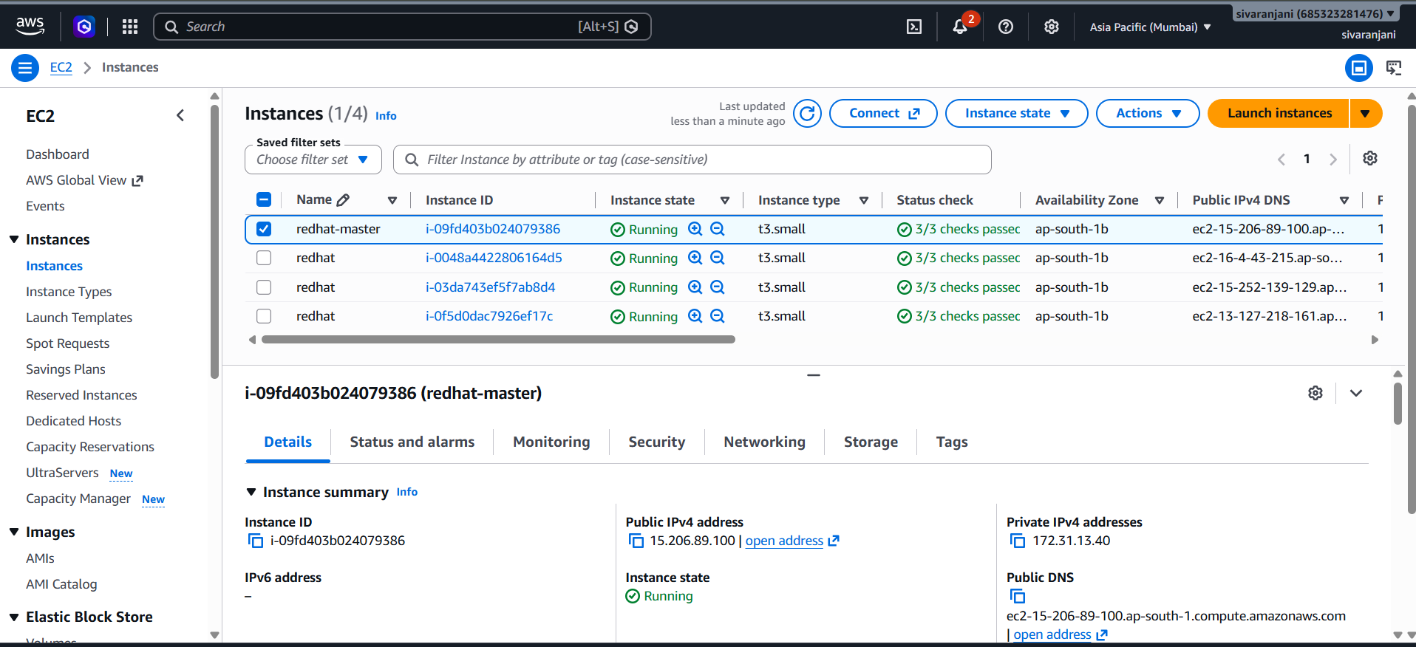
Connected to the master slave
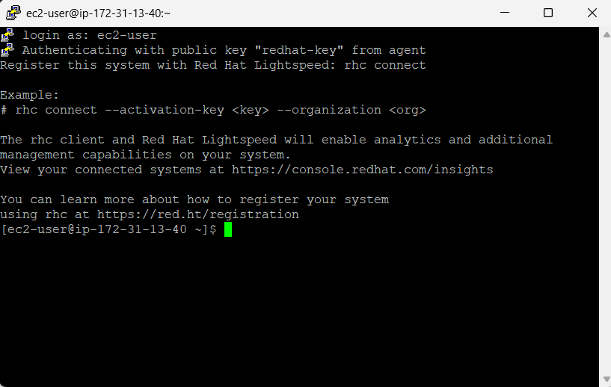
After adding slaves.txt and ansible.config , we’ll able to ping all slaves
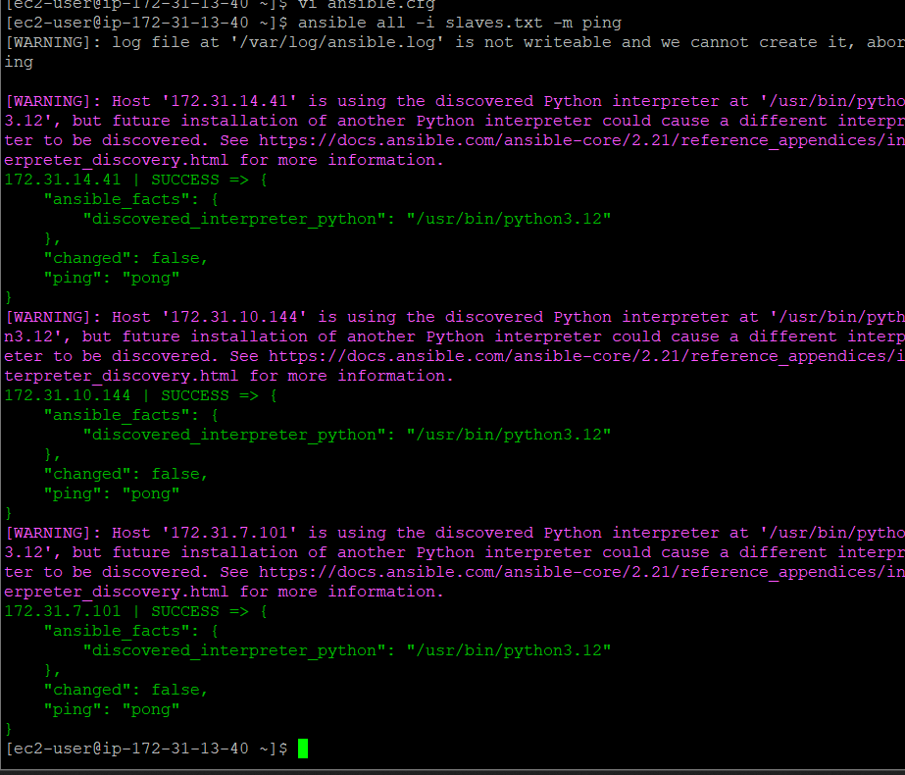
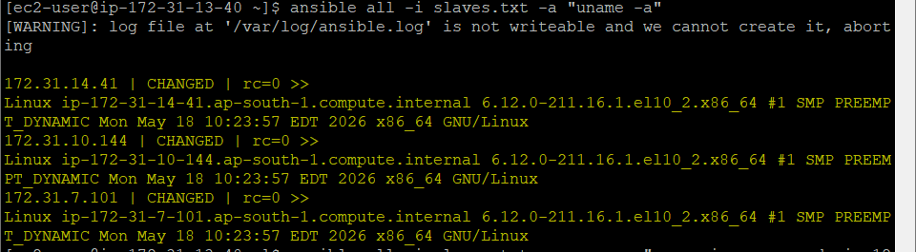
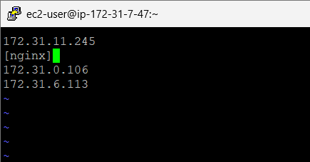
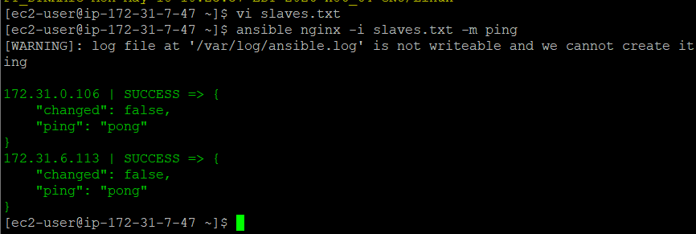
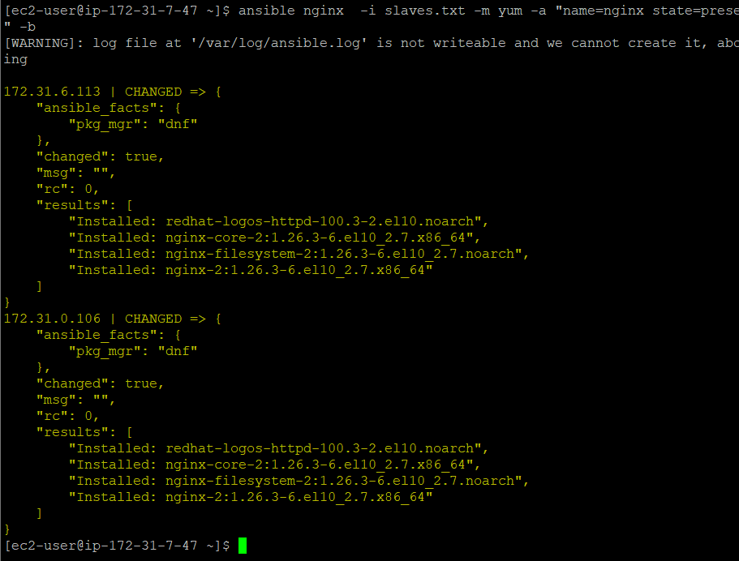
For redHat nginx serves website from /usr/share/nginx//html/s
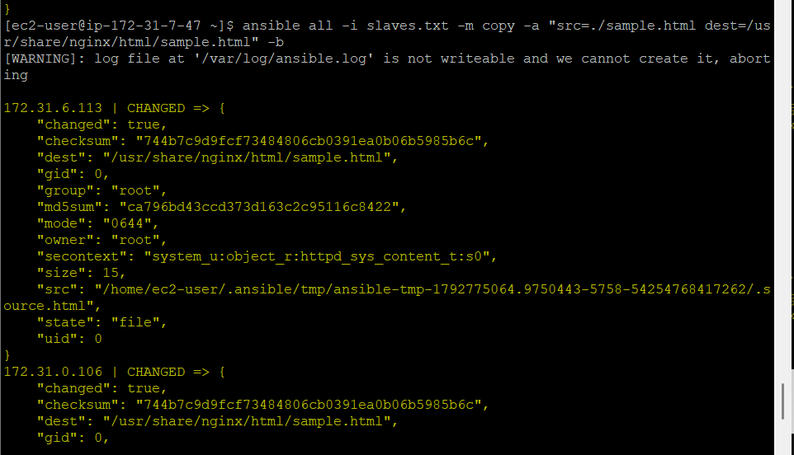
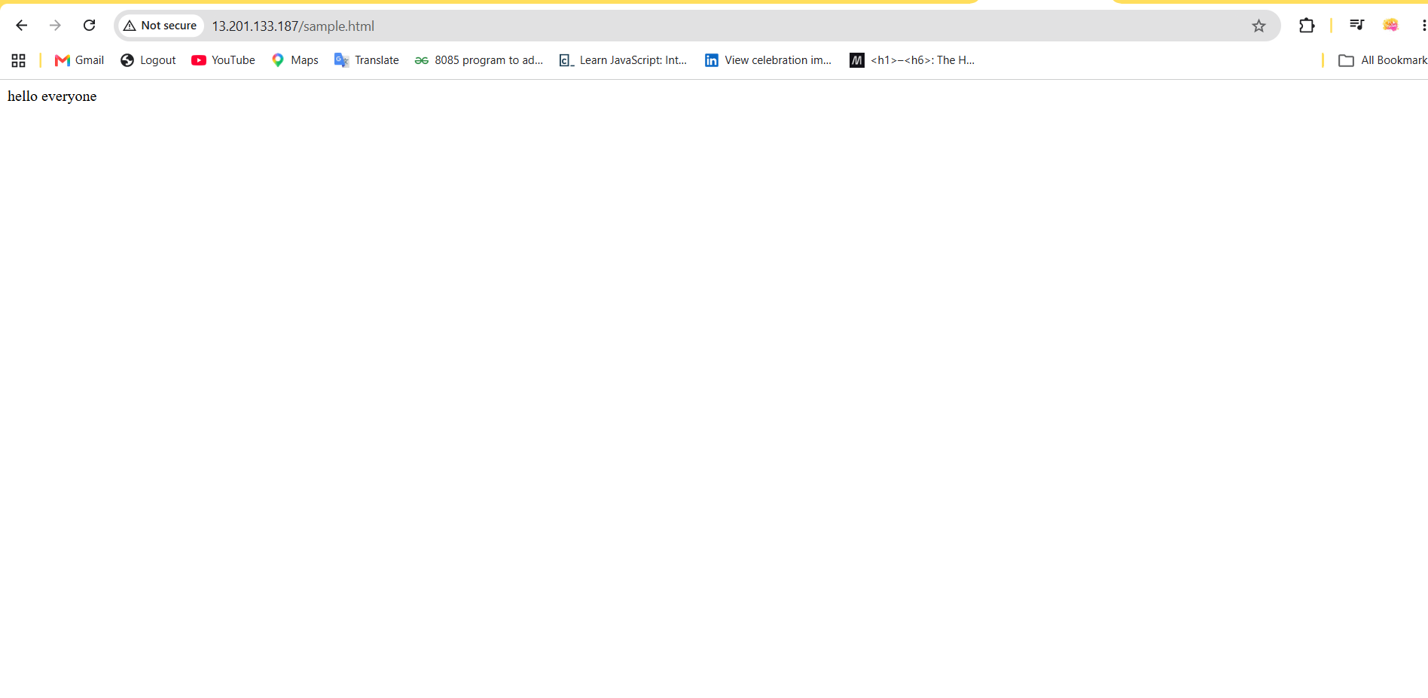

USER CREATION BUT PASSWORD IS NOT STORED
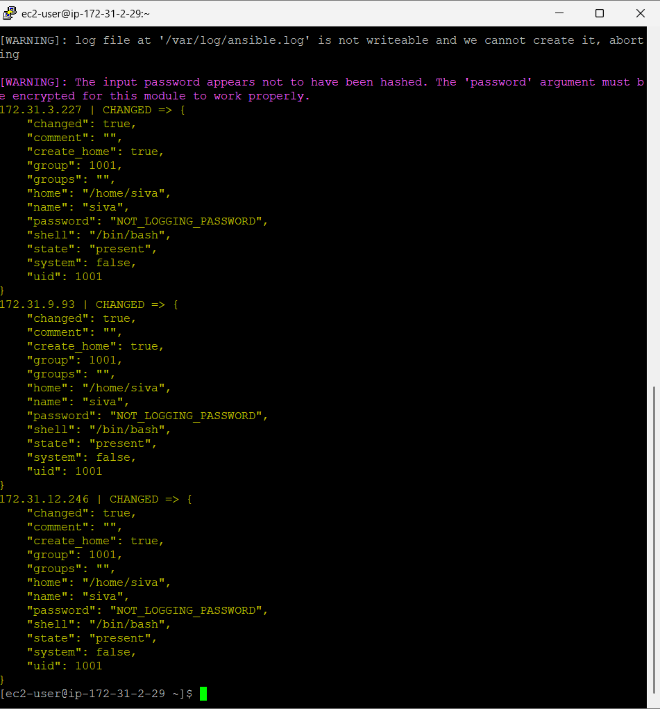
We can see password not logging. Linux normally stores the password in hash /etc/shadows . so need to install hashing crypt.
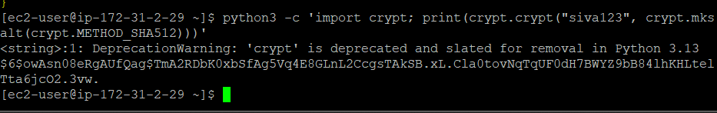
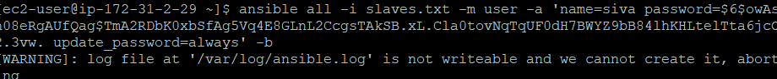
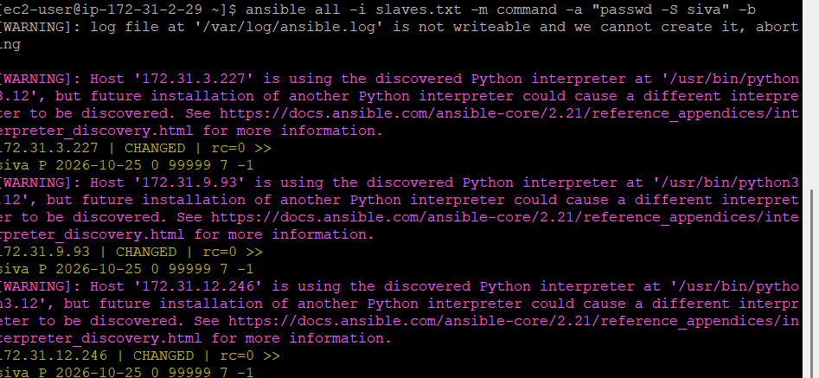
In the output , P = denotes the password is set , NP = no password set
Checking user by logging to one of slave machine
